Course Name: Forensic Science 1 Honors

Course Prerequisite: Biology 1 Honors or Teacher approval

Instructor: Mr. Eric Fernandez
Primary Email: efernandez@bdchs.org

Google Cellphone: 813-825-2615
BDCHS Landline Telephone ext.: 304
Classroom: 319
Office/Tutoring Hours:
Wednesday 3:15pm to 4:15pm or by appointment
Preferred Method of Contact:
Email, Canvas message or text message

Course Policies

Scholarly Demeanor: The School-wide Student Code of Conduct, PRIDE Expectations, and expectations in our Student and Family Handbook apply to both the face-to-face and the online formats. Additionally, all students will need to review and acknowledge the BDCHS Student Online Learning Expectations.
Accessing Course Materials and Daily Content: Lesson Plans on CANVAS
Accessing Assignment Details & Due Dates: Lesson plan on CANVAS
Accessing Daily Announcements: CANVAS Stream
Communication with Instructor: “Communication – the human connection – is the key to personal and career success.”
Paul J. Meyer
In order to connect with you and assist you develop academically, behaviorally and emotionally, we need to communicate as often and sincerely as possible regarding whatever is impacting your BDCHS life. I will answer any communications from students and parents as promptly as possible. I am successful at returning most communications within 48 hours. I try to answer communications as quickly as possible.
I expect student and parent responses to my communications to be prompt. While interacting in our eLearning as well as our Brick and Mortar environments, students should expect to interact with their teacher and peers academically on a daily basis.

Late Assignments: Assignments will be accepted in accordance with the Student Family Handbook. Please refer to our policies for further information. Students may receive assignment extensions on homework when discussed and agreed upon by the teacher.

BDCHS Policies:
- Attendance Policy: Refer to the 2022/202 Student and Family Handbook
- Academic Integrity:
BDCHS is committed to the academic integrity of all students. Academic integrity is grounded in fundamental principles such as honesty, fairness, and respect. Academic integrity involves the completion of all academic endeavors as representative of one’s own efforts. Knowledge and maintenance of academic integrity are the responsibility of the entire academic community, including both instructors and students. Students are responsible for understanding BDCHS politics related to academic integrity, and students are responsible for asking questions to clarify expectations.
  - Cheating is intentionally or carelessly acting dishonestly or unfairly in order to gain an advantage, and includes both plagiarism and illegal collaboration. It also includes utilizing resources explicitly prohibited by an instructor during an assignment, activity, or assessment. Students must consult with their instructors for clarification in any situation in which the ability to utilize outside resources (i.e. class notes, internet sites, textbooks) is a question, and will have cheated in any situation in which they utilize outside resources without prior permission. For example, the use of unauthorized aides such as translator applications, equation solvers, automated essay writers, or other similar services are typically not permitted in an academic environment. Use of such services without prior permission would be considered cheating.
  - Plagiarism is intentionally or carelessly presenting the work of another as one’s own. It includes submitting an assignment claiming to be the student’s original work which has wholly or partially been created by another person. It also includes the presentation of work, ideas, representations, or words of another person without customary and proper acknowledgement of sources. Students must consult with their instructors for clarification in any situation in which the need for citation is an issue, and will have plagiarized in any situation in which their work is not properly cited.
  - Collaboration is actively working with peers to create or complete something. Group study and group work have many advantages, but only when each student takes responsibility for mastering all course material before the group. For example, if working with a study group in a math class to complete homework problems, rather than each student only mastering a few problems, each student should complete all problems individually, and then share the task of explaining a few problems to the group.
Illegal collaboration occurs when students work separately on the same assignment (i.e. each completing one half of the activity) and each turn in the same assignment as their own original work. Students must turn in assignments that are substantially their own work. Group projects require careful division of responsibility and careful coordination. When necessary, ask the instructor to clarify individual responsibilities. It is ultimately the student’s responsibility to avoid crossing the line where collaboration turns to cheating.

The BDCHS Academic Integrity Policy was adapted from the Academic Integrity Policy utilized by the University of South Florida.

Please continue reading the Detailed course syllabus below

BDCHS Forensic Science
Detailed Course Syllabus
Mr. Fernandez
2022-2023 School Year
Course Topics:
Forensic science is the application of science to law and encompasses various scientific disciplines. This course will introduce various methodologies and applications used in the forensic context. Topics dis­cussed include: audio and visual surveillance, documentation, organic and inorganic chemical analy­ses of physical evidence, principles of serology and DNA analysis, identification of fresh and decomposed human remains, ballistics, fingerprint analysis, facial reconstruction, drug analysis, Forensic Entomology, Engineering Forensics, Computer Forensics, Forensic Anthropology, etc.
The Forensic Science class is designed around the idea that in the real world all learning is interrelated and interdependent. This class blends all of the sciences with the core subject areas. Students will be asked to read, research, hypothesize, interview, compute and use deductive reasoning to propose crime solutions and other solutions where applied. With an ever-increasing use of technology, the students will record data, draw conclusions, and formulate the best method for communicating results.
Integration is the method by which one learns. It connects subject areas and reflects what happens within the real world. Through forensic science, students become involved in many disciplines of study. They find value and relevance in what they study as they interact within the community at large.
The intention of this class, therefore, includes showing the interrelationships between all areas of study. It uses what is actually happening in the community, country and the world as its classroom and lab. As the student's improve on lab/field skills and procedures, they will exemplify what occurs in solving mysteries. As they improve their deductive reasoning and critical thinking skills, they will develop a lifelong learning style.
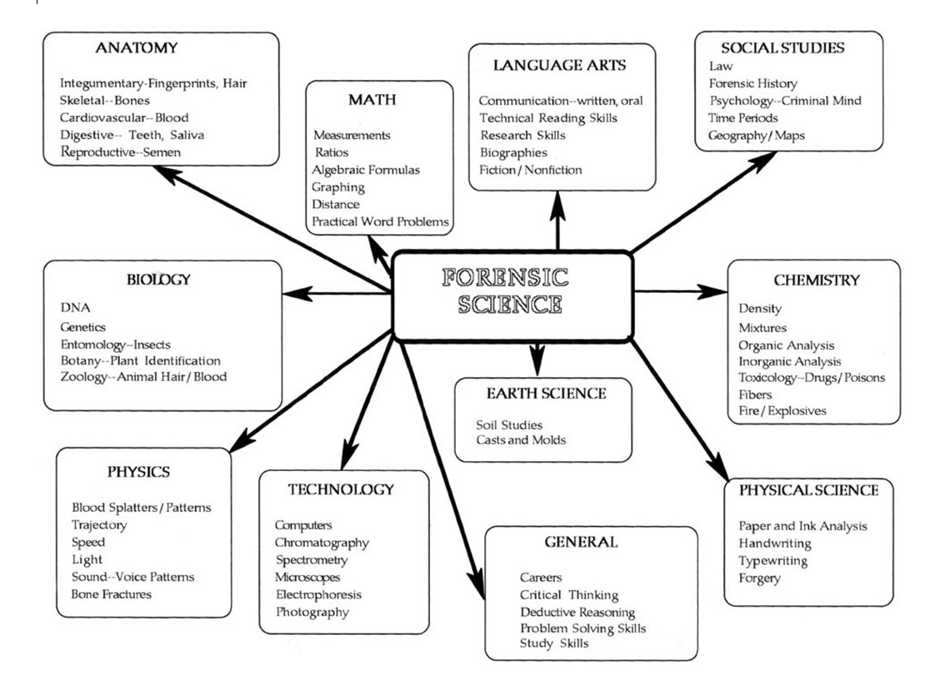
Key Words: Safety, Honor, Respect, Attitude, Excellence
Class Behavior and Expectations: Students are expected to conduct themselves at all times in a collegiate manner, to actively participate in all class activities, and to not be disruptive in any way during class time. The following list is not all-inclusive, but contains general rules for adult behavior in a workplace and classroom setting:
· All cell phones must be "OFF" during class. If you must use the phone, please consult your teacher
· NO TEXT MESSAGING to other students or to anyone outside of class
· No use of social media during class time
· Using the computers for anything other than course applications and class assignments is prohibited
· BDCHS dress code must be followed.

· Students are expected to pick up after themselves; Good Housekeeping practices will be followed at all times
· Water is permitted in class; Covered, spill-proof containers are preferred
· No excessive or disruptive talking and/or sidebar conversations.
· Be on time for class.
· Class participation is strongly encouraged and expected
Resources:
Online Resources on www.sdhc.Canvas, and in your Google Class: The materials found in the Experimental Science 2 Honors Course CANVAS Library and in your Amatrol course curriculum are the primary source for study materials for this class. Further supplementary material will come directly from student web searches, assignments, and projects.
Added Resources: Other resources may be added during the year. Online workforce training sites and other tools are planned for future application within the course framework These sites will be added to my Resource and information page during the year. This page is presently under construction.
Grading Category Values/Weights:
- Assessments (i.e. tests, quizzes, presentations, journal writings, projects, etc.) 60%
- Learning Experiences (i.e. including participation, specified assignments, activities, etc.) 40%
Grade Scale:
A 90-100% B 80-89% C 70-79%
D 60-69% F 0-59%
Assessments:
There are two types of assessments, Formative and Summative. Formative Assessments do not carry point values and are used by teachers, students and parents to measure student advancement towards mastery goals. Summative Assessments allow teachers to establish point values for grades. Both types of assessments can be based on activities such as traditional tests, journal write-ups, power points, videos, reconstructions, builds, play, oral exams, discussions, etc.
Mastery is the comprehensive knowledge or skill in a subject. While proficiency is a measure of the level of competence or skill attained by a student working towards mastery. Level of

proficiency and mastery are demonstrated via planned assessment, Failure to demonstrate adequate proficiency and mastery in a given assessment will result in a low grade. Grades can be improved once levels of proficiency and/or mastery are demonstrated by students that reassess. Students are encouraged to reassess when necessary and reassessment can take many forms depending on the needs of the student. Students interested in reassessing must take the initiative to discuss reassessing with their teacher. Reassessment strategies and dates will be agreed upon by the teacher and the student. As a general rule, reassessments are not administered during the class period. After school sessions and other times outside the class period are optimal for reassessment. The teacher may decide to reassess a student during a class period under special circumstances.
Learning Experience Policy:
If work has not been completed during class, it may be taken home and should be finished in a timely fashion. Learning experiences and/or assessments worked on at home must be completed as agreed upon with the teacher.
CANVAS Grades, Make- up Work and Extra Credit: Student grades are usually logged in CANVAS no later than seven days after the submission date of the item. An item not turned in by the submission date will acquire a zero grade, “blank grade” or other provisional grade (e.g. 50% of the grade value due to mastery made evident through skills or knowledge demonstrated by past participation or formative assessments/assignments) determined by the teacher. Changes in any grades (i.e. student determined unsatisfactory grade, zero grade or provisional grade) will be changed after a student/teacher agreement has been reached, made and satisfied. In some cases, a given assignment may require more than seven days to be graded. In these situations, students will be notified of the delay in a timely fashion.
Students are permitted to make up work that was assigned during an absence or absences. The specifics regarding when and how the work is turned in will be determined based on a teacher/student discussion. It is the student’s responsibility to inquire about and/or obtain missed assignments immediately upon returning to school. Please refer to the Student Handbook for specific details regarding the homework policy
Extra credit will not be extended to individual students. However, bonus points may be offered periodically to the entire class on tests, mini assessments, assignments/homework, projects, etc.

Lab/Field Research: The best way to learn science is to do science. Thus, we offer many hands-on experiences. Although BDCHS staff has worked hard to minimize risks to students in all activities, accidents and injury are still possible. For this reason, we have a Lab/Field Agreement that must be signed by both students and guardians before a student is allowed to participate in labs and field research.

Classroom Supplies: Below, is a list of supplies and materials that I recommend. If you have an alternative, successful and proven set of notes taking and organizational strategies, you may use the supplies and materials that best satisfy your needs. However, you should be able to maintain an 85% or higher GPA in this class. Failure to maintain a high enough GPA will result
in a reevaluation of your strategies and a recommendation to implement a more effective learning option.
1. Composition book (college ruled or graph paper type) for labs, studies, projects and reflections
2. One roll of paper towels
3. Calculator (Nothing fancy and same as used in other courses)
4. Watch or other time keeping device
Tutoring: Science tutoring will be held after school. Details for regular tutoring schedules will be discussed in class and approved by the BDCHS administration. Additional science tutoring will be scheduled depending on student needs and teacher availability.
Learning Materials and Media: Classroom activities will include slide shows, short videos, documentaries, nonfiction films and relevant theatrical portrayals, presented by the instructor. Students will produce and present multimedia presentations in a fashion similar to that of the instructor. These media tools are presented and graded based on standard rubrics.
Field Trips: We are considering all options for field trips relevant to this course. Information regarding field trips will be distributed during the course of the year so keep informed so that you can enjoy the adventures that are planned.
Please visit CANVAS and your Google Class for more information or Contact me at efernandez@bdchs.org, CANVAS message or by Google Cell Phone 813-825-2615.
Please Read this Document entirely (i.e. multiple pages)

A Note to the Parent(s) or Guardians of BDCHS Students
Syllabus, Laboratory Rules/Procedures/Information, Laboratory Agreement, Best Practices in Animal Handling and Care, Animal Handling Agreement
Dear Parent:
Brooks DeBartolo Collegiate High School (BDCHS) Administrative and Board policies closely govern a process for communicating with the parent(s) of a student. BDCHS also requires a student and his/her parent(s) to acknowledge and agree to abide by any and all school and classroom policies and procedures.

When students register for a Science course (e.g. Forensic Science Honors), they receive a science course syllabus, laboratory/field research science safety agreement, lab/field research safety rules, an animal handling agreement, and a description of best practices for animal handling.
In order to save paper, your valuable time and to allow for more ease in the process, students will receive their course syllabus online, as well as the laboratory/field science, animals handling agreement and information sheets online. Your child is responsible to access this information immediately, and along with you read thoroughly and electronically sign off that you have read, fully understand and agree to abide by the requirements. This letter and the rest of the first day packet is available on CANVAS.
The process is very simple and optional! If you prefer; print, sign, date and return all documents.
You may retype or simply copy and paste the agreement language shown below to your parent/guardian email address. Then send this new email with the information listed below in the box to your child’s science teacher at the teacher’s BDCHS email address. A response on this email cannot be accepted. Be absolutely sure to include your child’s and your names where referenced. Hit send and you are done! The response must clearly indicate that it was sent from the parent’s email address.
BDCHS SCIENCE DEPARTMENT’S ELECTRONIC AGREEMENT
FROM STUDENT AND PARENT
I, (parent name) and my child, (child’s name) have read the science course syllabus and fully understand the content of the subject and the requirements for the course.
I, (parent’s name) and my child, (child’s name) have read and fully understand the laboratory and field science and handling of animals’ agreements and will abide by the requirements and expectations of all three agreements.

Parents and students, please carefully read the documents below and return the Electronic Agreement or hard copies of all agreements (i.e. signed and dated by parents and students) by September 1, 2015. All Electronic Agreements should be sent to efernandez@bdchs.org or all hard copies should be turned in during the class period. Students will not be allowed to participate in laboratory/field activities or handle animals if these agreements are not returned, properly filled out.

Parents/Guardians and Students: Please Read
Laboratory and Field Research Safety Rules!
- SAFETY IS OUR NUMBER ONE CONCERN.
- Always get permission before starting an experiment OR handling the equipment.
- Study the procedure. If you have questions – ASK.
- Use all safety equipment provided. Goggles are required when using chemicals or heat. Wear closed shoes to protect you from spills. KNOW the location of all safety equipment.
- NEVER eat or drink in the lab (this includes GUM). Don’t inhale (breathe in) the chemicals. Don’t taste anything without permission. In other words – don’t put anything into your mouth!
- NEVER “horse” or “play” around. This almost always leads to accidents and WILL RESULT in an automatic suspension from the lab and/or a referral to the assistant principal. Remember, you or someone else getting hurt, plus a zero on the lab grade is too high a price to pay for a little “playing” around.

- Chemical Labs: If you spill anything, report it immediately and wash it off according to your teacher’s directions. Never use a chemical from an unlabeled container.
- Always slant or tilt a test tube away from people while heating. Heat slowly to avoid spattering.

- If you need to smell test a substance, hold the bottle away from you and waft (gently fan) the fumes toward you.
- Fire burns. Keep all materials, including papers, books and your clothes away from open flames. Tie back long hair.
- Report all accidents no matter how small. Know the location of all safety equipment, including first aid.
- Clean your work area before leaving the class. Follow these guidelines:
  - Turn off gas and water, disconnect electrical devices.
  - Return all materials to their proper place.
  - Dispose of chemicals and other materials as directed by your teacher.
  - Put broken glass and solid substances in the proper containers. Never discard materials in the sink.
  - Clean your work area. Wipe off the tables and make sure that there is not trash on the floor or in the drawers or cabinets.
  - Wash your hands after working in the lab. Remember, even some rocks and minerals are poisonous.
Laboratory/ Field Research Safety Information
Throughout this year in science, your child will be working in the laboratory and or in the field on a regular basis. It is important for everyone’s safety that the following guidelines be followed in all lab/field experiences.
Know the location of safety equipment and follow our discussed procedures if the need
arises.
Everyone reports an accident, even minor ones, to the teacher. If an accident occurs and something is broken or spilled, alert the teacher to get assistance.
Eye goggles must be worn correctly when working with glass, flame, or chemicals.
Pull back hair and keep it fastened so that it does not come in contact with burner
flames.
Use the broken glassware box for only broken glass, the trash cans for paper and
matches, the sink for disposable liquids and authorized solids, and the disposal bucket
for others.
Seats or stools are used while conducting labs. Shoes are worn to protect the feet.
Absolutely no eating or chewing of any substance in the lab without the teacher’s
permission.
Leave reagents and chemicals in their correct places. NEVER pour unused chemicals
back into stock supply bottles.
Lab equipment and materials cannot be removed without teacher’s permission.
Seek permission before trying any experiments other than the assigned one.
All chemicals used in the lab should not be tasted, touched, smelled, or made to burn.
Follow directions given by the teacher and the lab report. Everyone is responsible for
knowing what to do. If unsure, then ask for assistance.
Explore science by utilizing the lab properly to maximize your learning and others too.
See Form Below
Hard Copy Form
Laboratory/Field Research Safety Agreement
The indoor lab and field labs are places for serious effort. Practical jokes and horseplay have no place in the science laboratory. Although it is possible for accidents to occur, students should not be afraid to use the lab equipment and chemicals.
I have read the Laboratory/Field Research Guidelines. We have discussed them and modeled them in class. I understand what is expected and will follow these rules or risk being suspended from lab activities. I understand that the laboratory rules and procedures apply to both indoor and outdoor laboratory settings.

Student’s Name __________________________________________________________

Student’s Signature ____________________________________ Date ______________

I have read these Laboratory Guidelines and have discussed them with my child. I am also concerned with lab safety and will support these to ensure a good learning experience for all students.

Parent’s Signature______________________________________ Date______________

I believe in regular lab/field experiences being one of the ways to teach science. Everyone’s safety is always my concern. I have taught these expectations thoroughly and will reinforce them continuously throughout the year.

Teacher’s Signature ____________________________________ Date_______________

Best Practices in Supervised Animal Handling and Care
Definition of Handling: For use in this document, handling means the holding, touching, cleaning, or supporting in anyway of an organism’s body or any associated object, water dish, domicile (i.e. cage, terrarium, aquarium, pet carrier, etc.), top, lid, and/or door.
Teacher supervised touching of an animal is not considered to be handling under this definition.
1) Never handle an animal without the teacher’s permission
2) Respect all animals and those people around you
3) Never approach, chase and/or tease a person who does not want an animal near them.
4) Ask permission before approaching anyone with an animal.
5) Keep animals away from people’s faces
6) Wash your hands with soap and water/ hand sanitizer before and after handling an animal.
7) Avoid bites; they are often more damaging to the animal than to the person bitten.
8) Always be aware that animals suffer pain, fear and nervousness just like us.
9) Treat animals the same way you would want to be treated by a giant.
10) Support the animal’s body as much as possible.
11) Never give an animal to unauthorized individuals.
12) Learn the proper way to clean cages, feed and/or work in any way with our classroom animals.
13) Never prod, poke, jab or make fast motions around an animal
14) Never tap on the animal’s domicile.
15) Help keep animals and their domiciles clean.
16) Beware all animals can bite and need to accomplish bodily functions.
17) Wear protective covering when handling animals, or risk possible consequences.
18) Make sure that all animals are placed in their proper home and that all doors, lids and tops are completely closed and totally secured before leaving the classroom.
19) Always cleanup any messes you and/or your animal has made in the classroom.
20) Do not feed the animals or place objects into their space without authorization.
21) Help others to understand the beauty and wonders of Life.

Hard Copy Form
Supervised Animal Handling Agreement
Handling Animals is a serious responsibility. Any living creature must be treated with respect and appreciation. Practical jokes, horseplay, chasing or scaring people with animals must never occur. Any animal with a mouth can bite. Also, animals may stain clothing while undergoing unexpected bodily functions. Although it is possible for bites and/or accidents to occur, students are allowed to handle animals when authorized by their parents/legal guardian.
I have been trained in the best practices for handling animals. We have discussed them and modeled them in class. I understand what is expected and will follow these rules or risk having my animal handling privileges revoked.

Student’s Name __________________________________________________________

Student’s Signature ____________________________________ Date ______________

We have discussed the best practices for handling animals with my child. I am also concerned with the safe and handling of animals and will support these to ensure a good learning experience for all students.

Parent’s Signature______________________________________ Date______________

I believe that interaction with other forms of life is one of the best ways to teach science. Everyone’s safety is always my concern. I have taught these expectations thoroughly and will reinforce them continuously throughout the year.

Teacher’s Signature ____________________________________ Date_______________

